# Table of Contents

**Network-as-a-Service Runbook**

***MOP RAN Installation Template***

**<NaaS Operator’s Name>**

**

*<Release Date>*

Table of Contents 1

1 Document Control 4

2 About Design Template 5

2.1 Document Purpose 5

3 Access Request 6

4 Health & Safety Measures 6

5 Pre-Installation 7

5.1 Site Material Received 7

5.2 Details of tools and testers 8

5.3 Verify Weather Conditions 8

5.4 Winch Installation 8

6 Connection Diagram 9

7 Equipment Description 9

8 Antenna Installation 10

8.1 Locate Installation place as is indicating in Engineering Designs : 10

8.2 Lift the Antenna 10

8.3 Install the Antenna 11

8.4 Connect the RF Cables into the Antenna 13

9 Radio Unit Installation 14

9.1 Locate the Poles where Radio Unit will be installed 14

9.2 Radio Unit Lifting. 14

9.3 Installing the Radio Unit on a Pole 15

9.4 Cabling the Radio Unit on ground 16

9.5 Cabling the Radio Unit to the Antenna 16

9.6 Cabling DC Cable on Radio Unit 17

10 Installing the Opting Fiber 18

11 Cabinet Installation 20

11.1 Clearance Requirements 21

11.2 Installing the Cabinet on the Floor 21

11.3 Grounding the Cabinet 22

11.4 Cabling 22

11.5 Routing Cables 24

11.6 Base Station Installation 25

11.7 Mounting Base Band on the Cabinet 25

11.8 Mounting Base Band Unit (Indoor Scenario) 26

11.9 Mounting Base band Boards 26

11.10 Power Cabling the Base Band Unit 27

12 Labeling 27

13 Annex A 28

# Document Control

- Revision Control sheet allows to maintain a record of changes made on the document.

|  |  |  |  |
| --- | --- | --- | --- |
| Version N° | Issue Date | Status | Reasons for Change |
|  |  |  |  |
|  |  |  |  |
|  |  |  |  |
|  |  |  |  |

Table 1. Revision History

# About Design Template

## Document Purpose

The purpose of this document is provide guidelines and a sample of a Installation Method of Procedure of a LTE Base Station of any kind.

# Access Request

* The Access Request Form must include the following:
* Name, Position and ID of the Tower Access Seeker proposing to access the Tower,
* Details of the company for which the Tower Access Seeker works,
* Site on which the Tower is located,
* Proposed date(s) and time(s) of access and proposed duration of the works,
* Purpose of the access,
* Equipment that will be required for the works,
* Scope of Works (SOW),
* Method of Procedure (MOP),
* Safe Work Method Statement (SWMS),
* License or certification for the operation of any major equipment to be used , for example using an elevated work platform (EWP), scissor lift or cherry picker, Copy of Climbing
* Certificates / licences (riggers),
* Copy of Tower Rescue Certificates (riggers),
* Copy of Medical Certificates,
* Copy of First Aid certificates,
* Any other information required by applicable work health and safety laws and regulations for applicable jurisdictions (for example in NSW the Work Health and Safety Act 2011 (NSW) and Work Health and Safety Regulations according to local regulations (NSW)).

***Insert the Naas Operator Access Procedures***

# Health & Safety Measures

* Before any person shall commence a tower climb, they must:
* Familiarize themselves with the risks at the Site and on the Tower and understand the risks
* Inherent in working in an RF environment and be aware of the “go/no go” designated areas.
* Be fully conversant with the operation of all safety equipment and techniques; and
* Take into consideration current and predicted weather conditions and take the requisite
* Precautions to prevent exposure and potential slip hazards.
* During the climb each person must:
* Limit their work on the Tower solely to the area and work approved on the Tower Access
* Request Form and within daylight hours on a Monday to Friday basis,
* carry a means of portable communications,
* Verify the presence of fire extinguisher and first aid Kit

All NaaS Operator Field Workers that will work in tower site must wear their PPE this requisite is mandatory :

|  |  |  |
| --- | --- | --- |
| Panoramic eye protectors |  |  |
| Helmet with chinstrap for work at height |  |  |
| Dielectric safety footwear |  |  |
| High abrasion gloves |  | Abrasion Resistant Work Gloves | Aviation Spares & Repairs |
| Dielectric gloves |  |  |
| Full body safety harness |  |  |
| Double lashing strap (monkey tail) |  |  |
| Suspension strap |  |  |
| Positioning belt |  |  |
| Life rope |  |  |
| Save sliding falls (lifeline) |  | Miller Guide - Smart Policy Safety Compliance at Height |
| Safety belt |  |  |

***Insert the Naas Operator Health and Safety Procedures***

# Pre-Installation

## Site Material Received

|  |  |  |  |
| --- | --- | --- | --- |
| **SI Code** | **Description** | **Delivered** | **Comments** |
| RRU01 | Radio Unit | Good | NA |
| TRBD01 | Transmission Board |  |  |
| SRCK01 | Base Band Sub rack |  |  |
|  |  |  |  |
|  |  |  |  |
|  |  |  |  |
|  |  |  |  |

***Insert the Naas Operator Equipment and Material List***

## Details of tools and testers

|  |
| --- |
| 1. Screwdriver Set: Knurled-Head. |
| 2. TORX Screwdriver set: T10, T20, and T25mm. |
| 3. Side Cutter. |
| 4. Monkey Wrench. |
| 5. Wrench 13mm (0.51 inch.). |
| 6. Torque Wrench for Feeder Connectors, Battery Terminals etc. |
| 7. Crimping Tool for 16Sq.mm to 70Sq.mm cables. |
| 8. Hammer Drill. |
| 9. Measuring Tape (30M). |
| 10. Tool Case. |
| 11. Hex-Box Spanner set |
| 12. Multigrip Pliers |
| 13. Cable ties cutter. |
| 14. ESD Wrist Strap and cable. |
| 15. Allen Key set |
| 16. Folding knife. |
| 17. Marker Pen or Comparable tool. |
| 18. Levelling tool. |
| 19. Extension Board. |
| 20. Scissor. |
| 21. Flashlight or torch. |
| 22. 1.5 m (5ft) high safety ladders |
| 23. Site Master which includes VSWR, Power & Frequency Meter (Anritsu/Bird) |

***Insert the Required Tools to perform the Installation***

## Verify Weather Conditions

Winds higher than 30 km / h, ice formation and/or snow accumulation, its required to suspend work at height, except critical areas, where works must have an authorization explicitly by engineering and must be informed the chief of operations before implementation.

## Winch Installation

The elevation of the components in height, both electronic and support, may be made with Winch with steel cable and brake. The winch will be fixed to the structure or anchors well secured.

# Connection Diagram

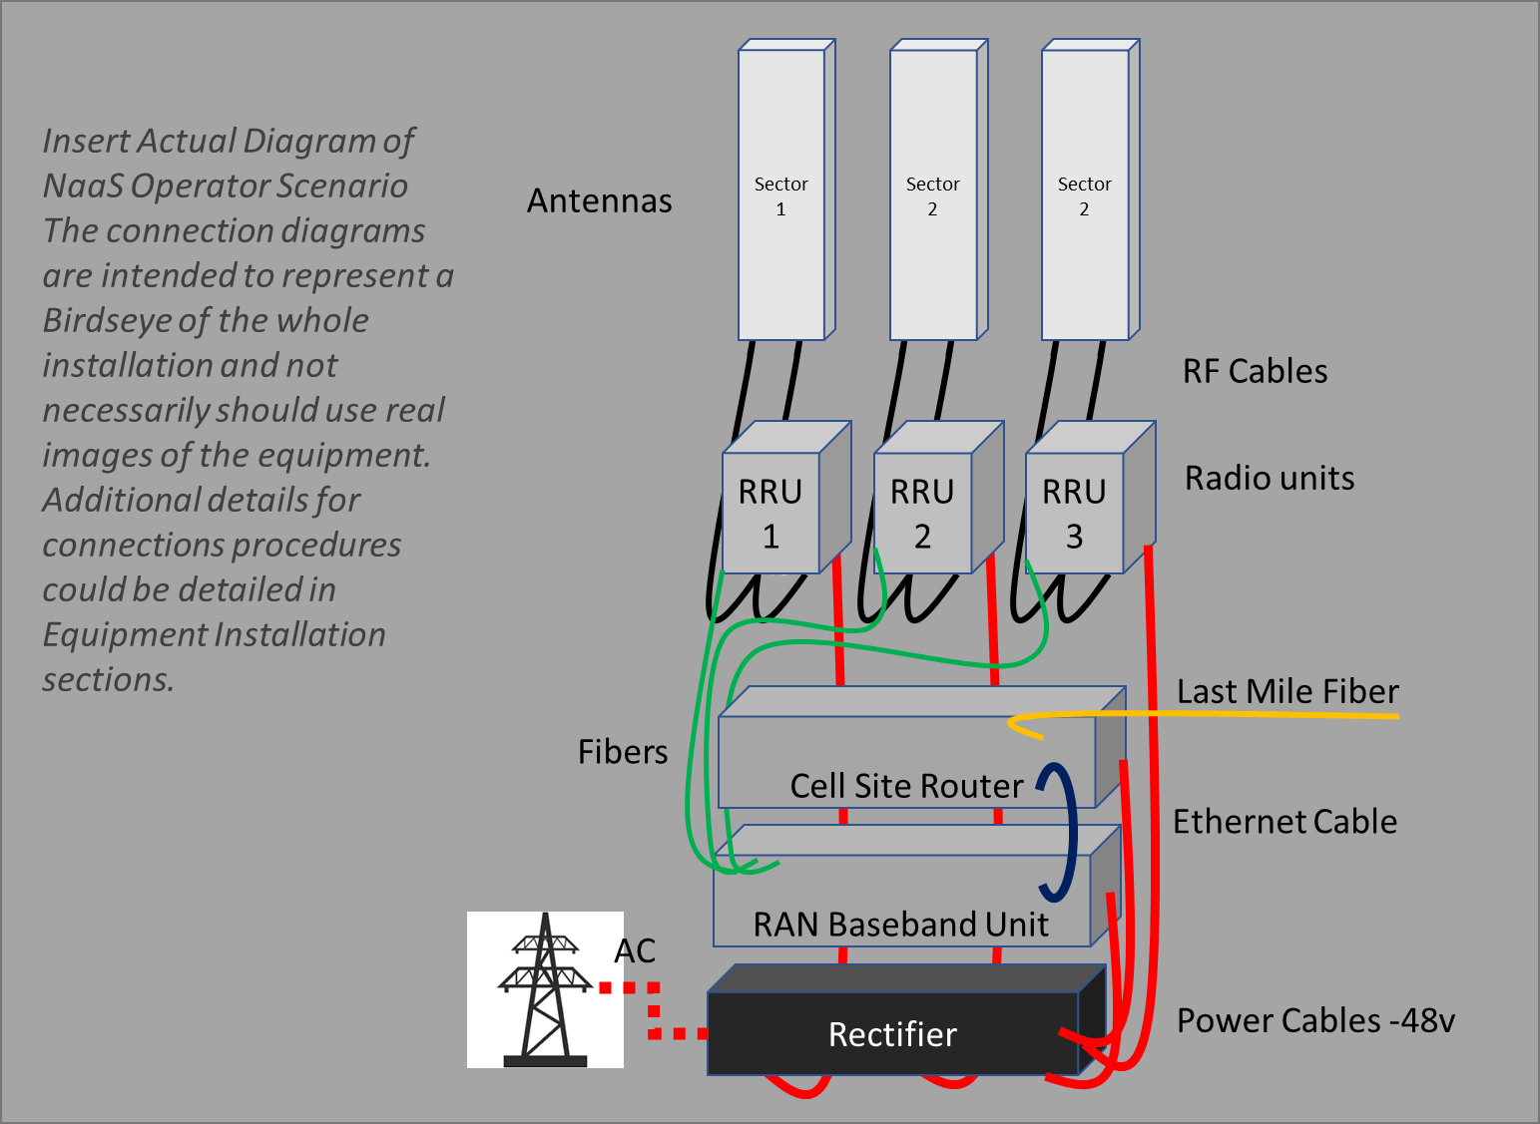

*Depending on the complexity of the scenario the connection Diagram could cover all connections in a single diagram or could be split, for example, Power Connections in one diagram fibers and RF connections in another diagram.*

# Equipment Description

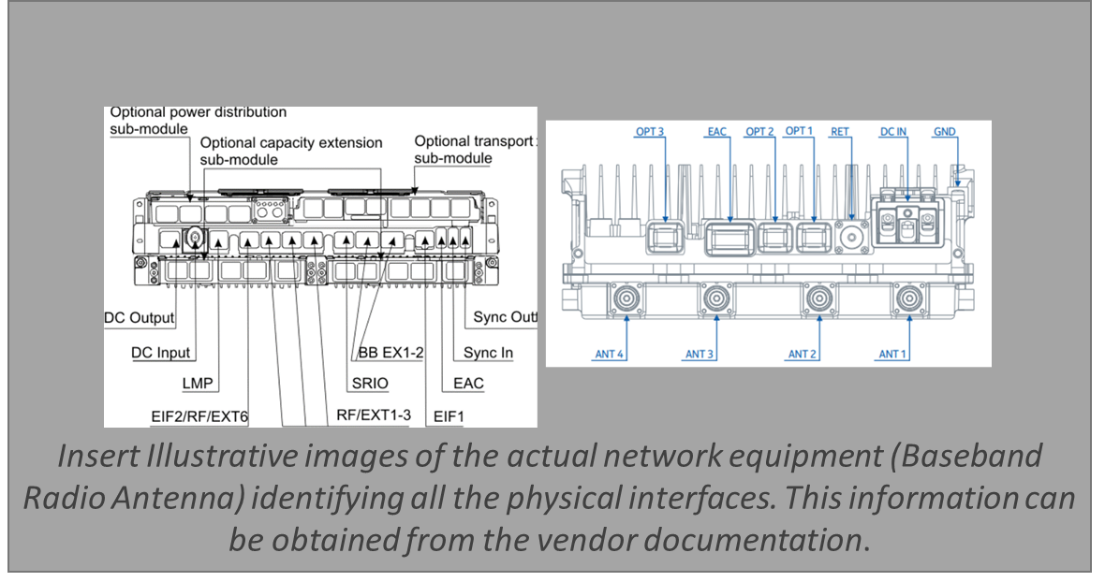

# Antenna Installation

## Locate Installation place as is indicating in Engineering Designs :

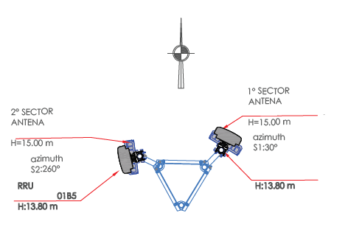

***Insert Actual Tower Designs that detail height, azimuth and location of the Antennas***

## Lift the Antenna

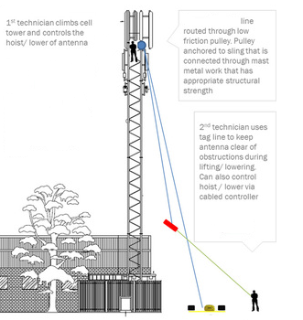

***Insert Step by Step Instructions to lift the Antenna***

## Install the Antenna

Preassemble in ground following items:

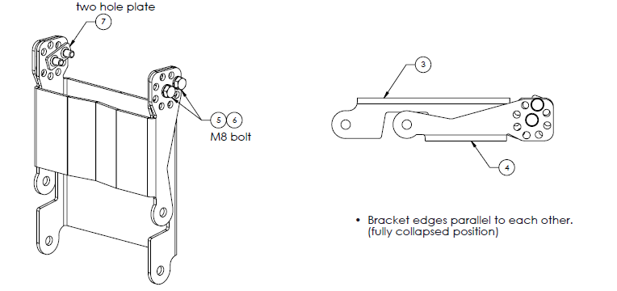

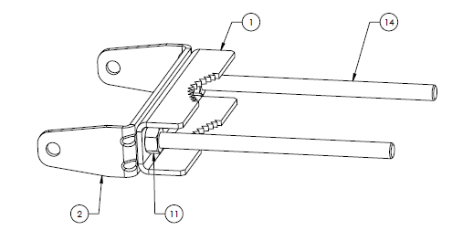

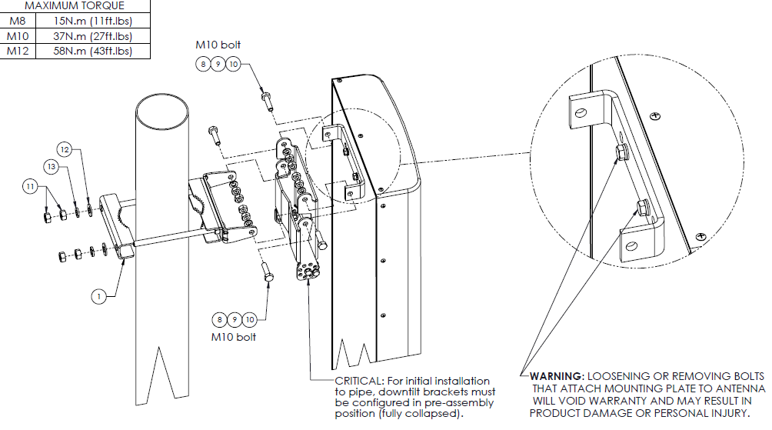

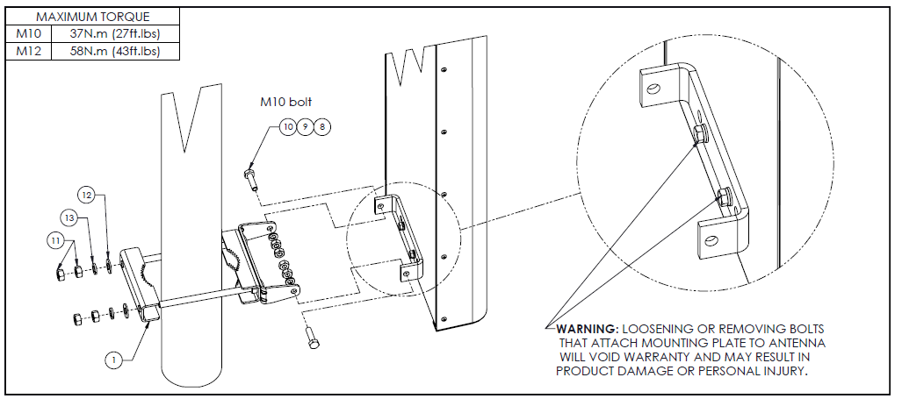

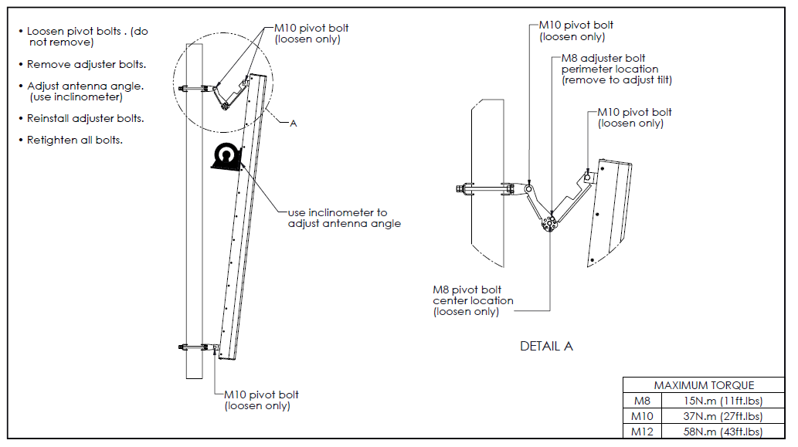

***Insert STEP BY STEP Antenna Installation Instructions (Preassemble everything that is possible in ground such as pivot bolts)***

## Connect the RF Cables into the Antenna

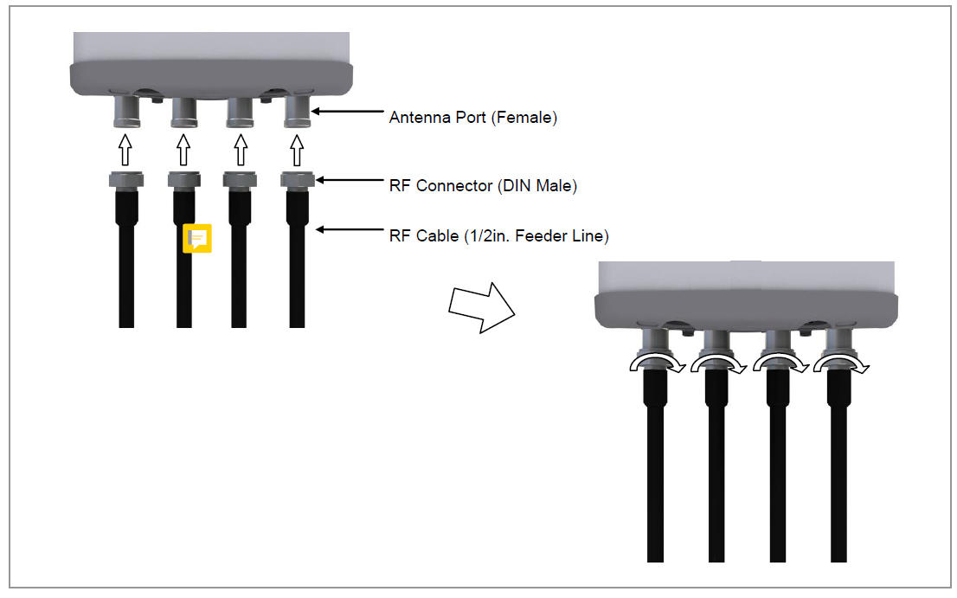

***Insert a diagram that shows a connection exactly as the NaaS Operator Engineering solutions***

# Radio Unit Installation

## Locate the Poles where Radio Unit will be installed

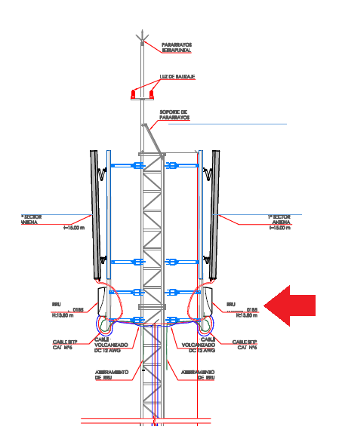

***Insert actual engineering diagrams of the pole where RRU will be installed***

## Radio Unit Lifting.

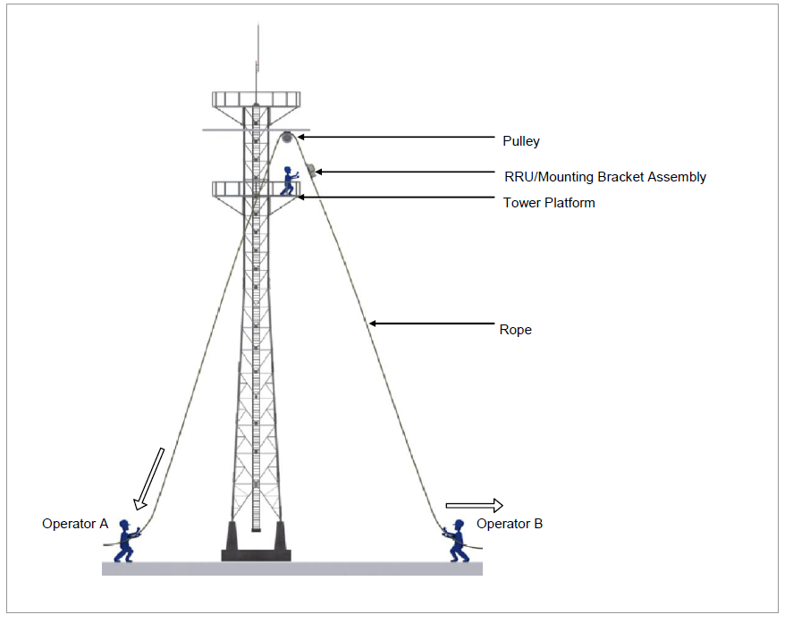

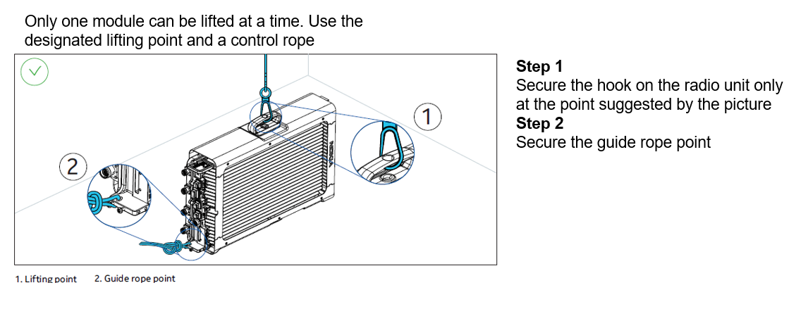***Insert Step by Step instructions to Lift the Radio Unit***

## Installing the Radio Unit on a Pole

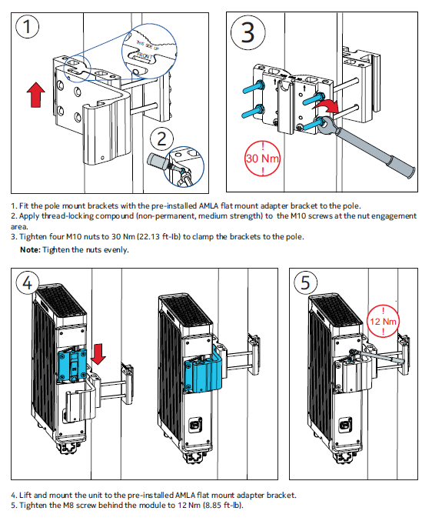

***Insert Step by Step mounting radio unit installation instructions***

## Cabling the Radio Unit on ground

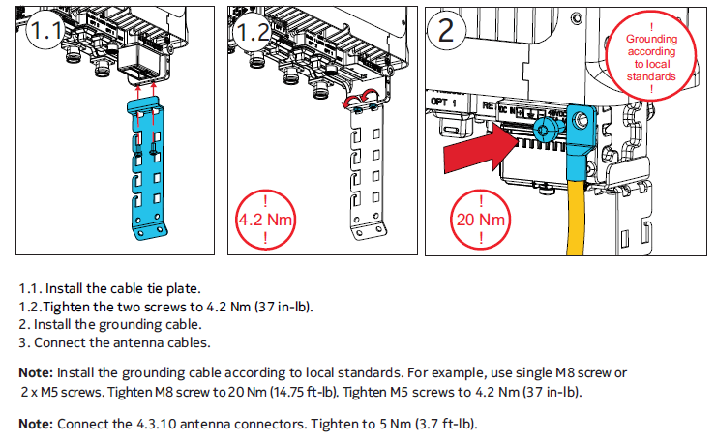

***Insert Step by Step Installation Instructions to cable the radio unit to the ground***

## Cabling the Radio Unit to the Antenna

In cases where there is 3m bridges, please evaluate whether the surplus can be left inscribed or combed (radius of curvature 20cm) .



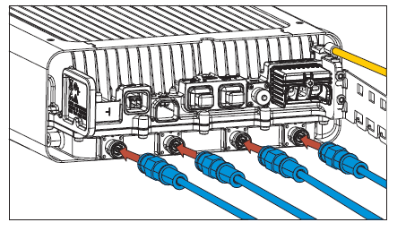



***Insert Step by Step Installation Instructions to RF Cables (Please note that some vendors require additional isolation procedures)***

## Cabling DC Cable on Radio Unit

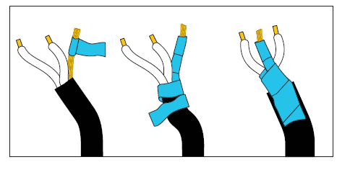**a)** Strip about 10 cm (4 in.) of the DC cable and wrap

tape around the GND meshand cable sheath neck.

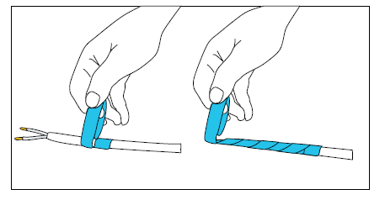

**b)** Wrap extra tape around the exposed wires to prevent

the IP boot from tearing(when routing the cable

through the boot).

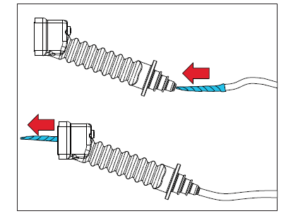**c)** Insert the taped end of the DC feeder cable into

the IP boot and feed it through.

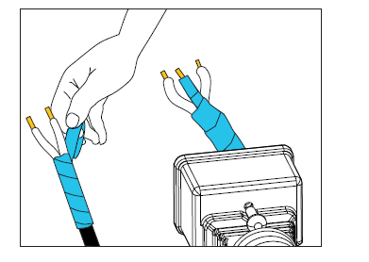**e)** Remove the extra tape from the DC cable.

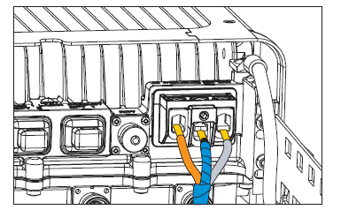**f)** Connect the wires to the screw terminal.

Tighten to 3.0 Nm (27 in-lbs).

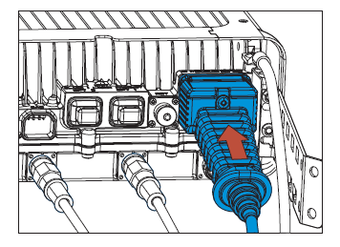**g)** Connect the wires to the screw terminal.

Tighten to 3.0 Nm (27 in-lbs).

***Insert Step by step Procedures for DC Cable the RRU ( Best Practice Do it on the floor)***

# Installing the Opting Fiber

Define the arrangement of cable going down from radio units and the procedure:

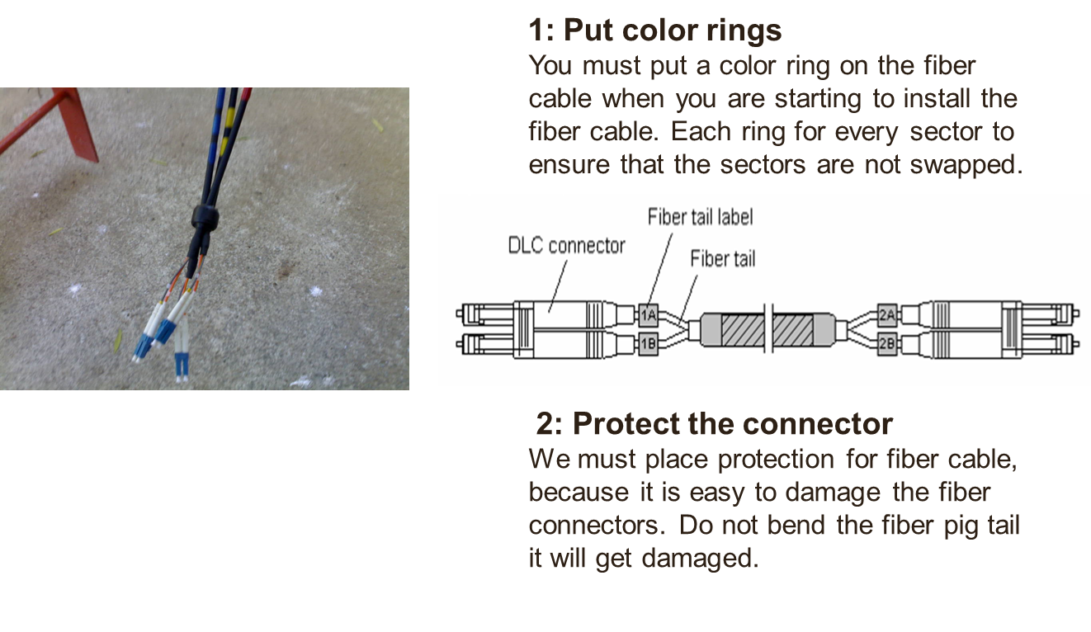

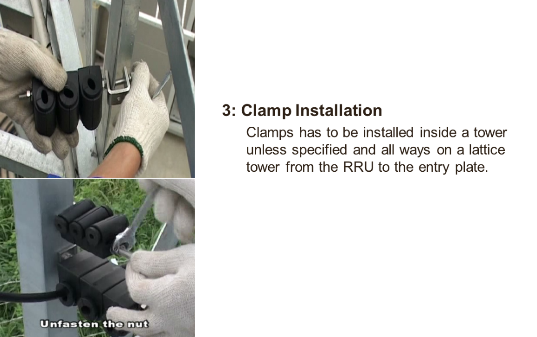

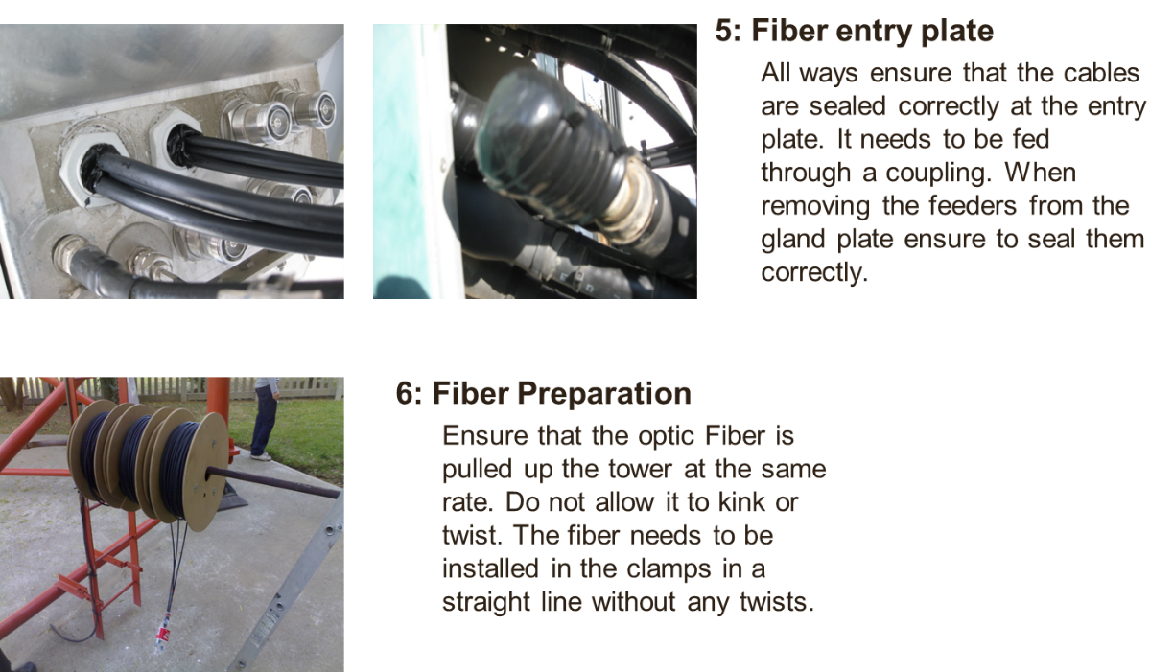

***Insert a Step by Step Procedure for Fiber and Power Cables going down from Radio Units from to Band Unit***

# Cabinet Installation

For Outdoor Installation Scenario :

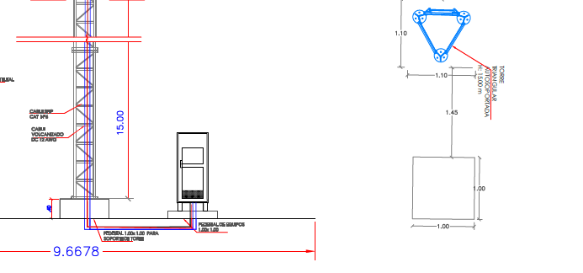

***Locate the cabinet installation according to Engineering Site Draws***

## Clearance Requirements



***Insert Illustrative images of the actual clearance requirements of the cabinets (Baseband Radio Antenna). This information can be obtained from the vendor documentation.***

## Installing the Cabinet on the Floor

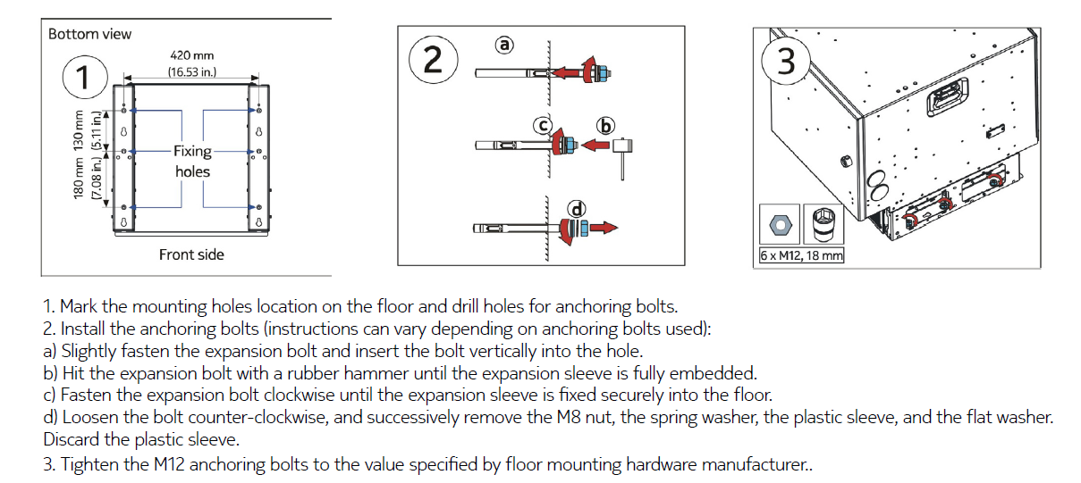

***Insert Step by step instructions associated with actual diagrams or image of the cabinet***

## Grounding the Cabinet

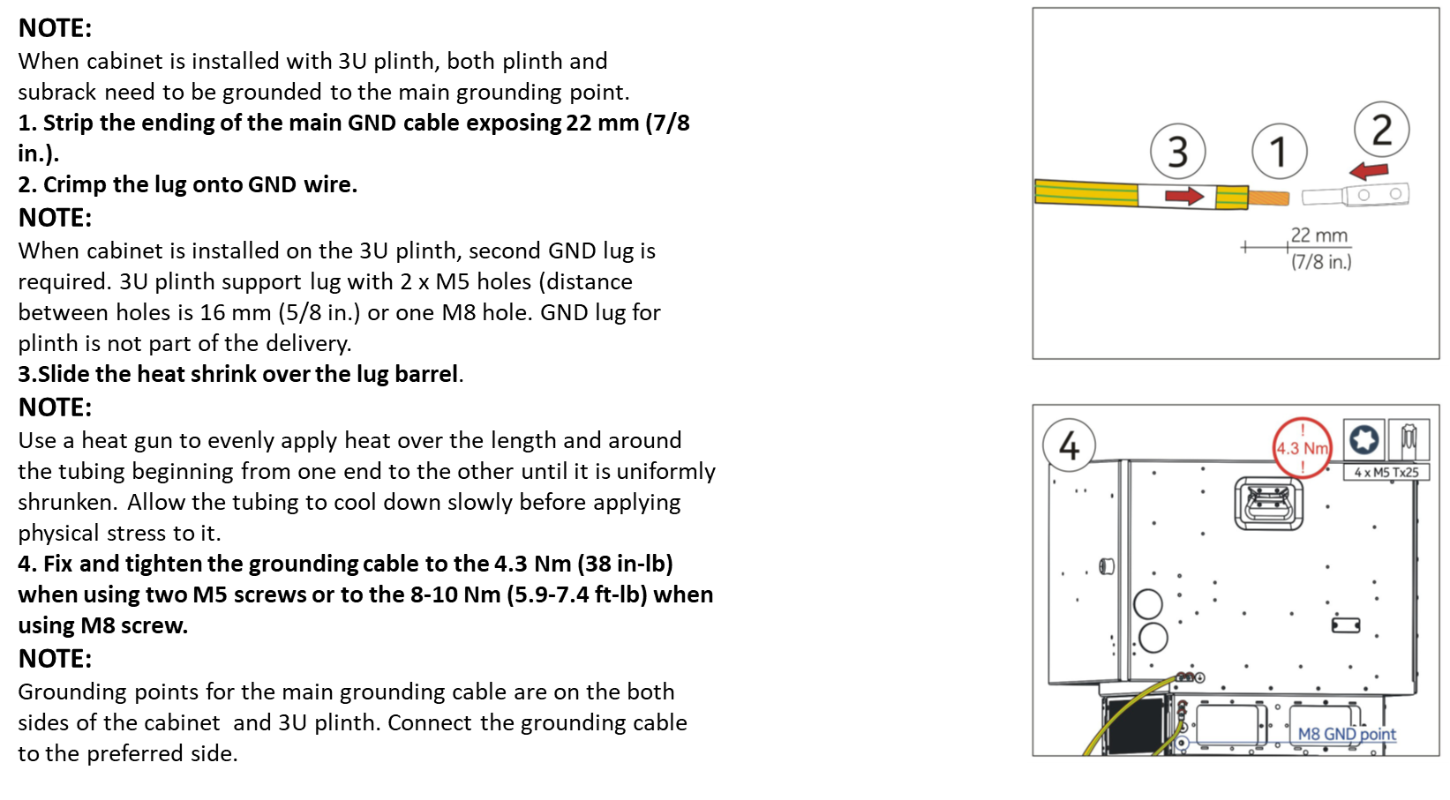

***Insert Step by step instructions associated with actual diagrams to grounding the cabinet***

## Cabling

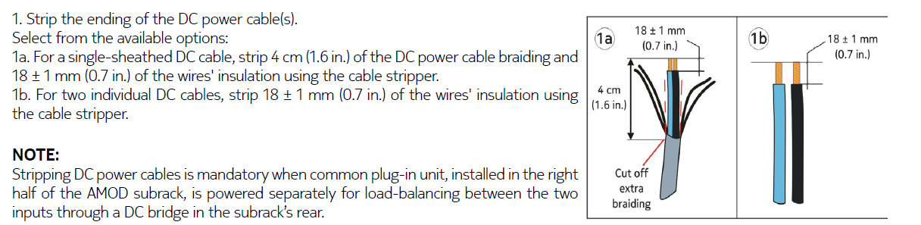

***Insert Step by step instructions for DC Wiring***

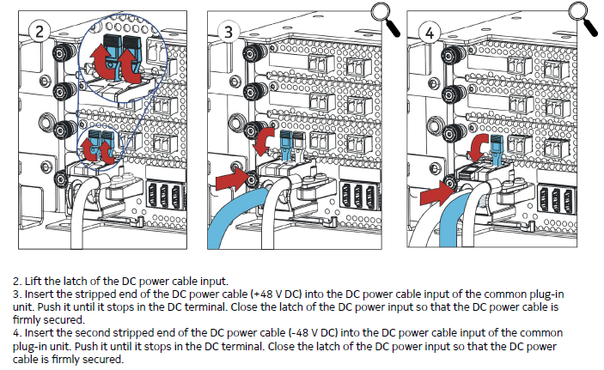

***Insert step by step instruction for connecting the power cable***

## Routing Cables

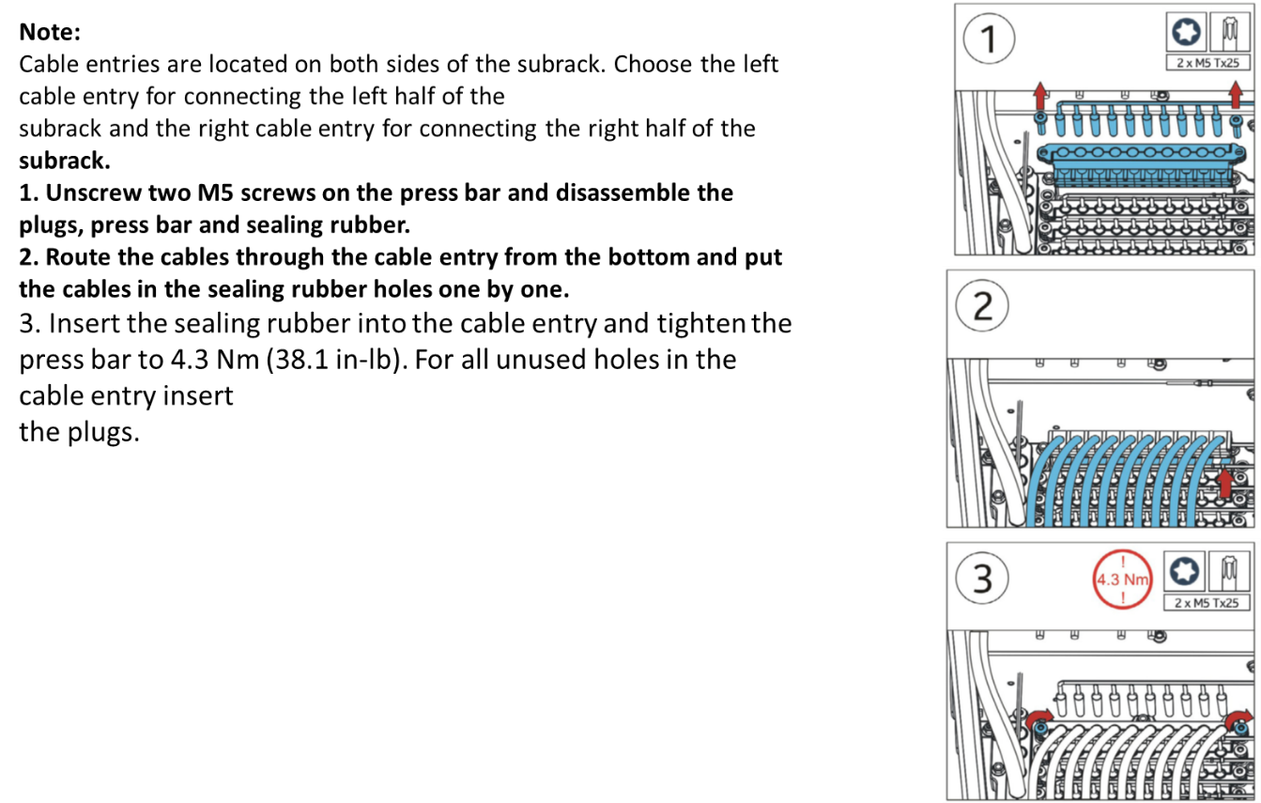

***Insert Step by step instructions associated with actual cabling routing***

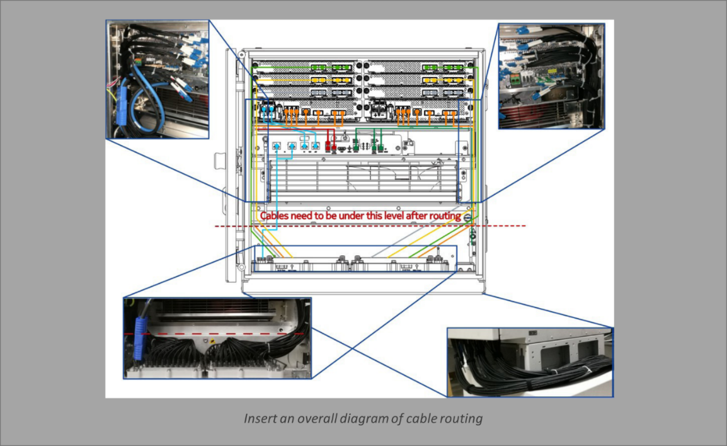

## Base Station Installation

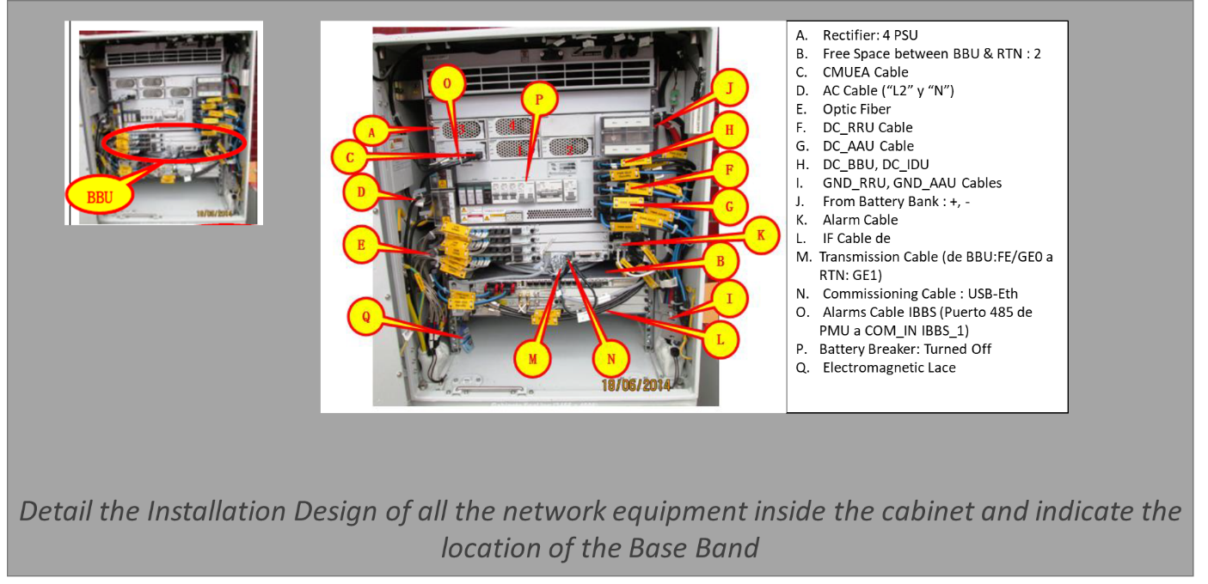

## Mounting Base Band on the Cabinet

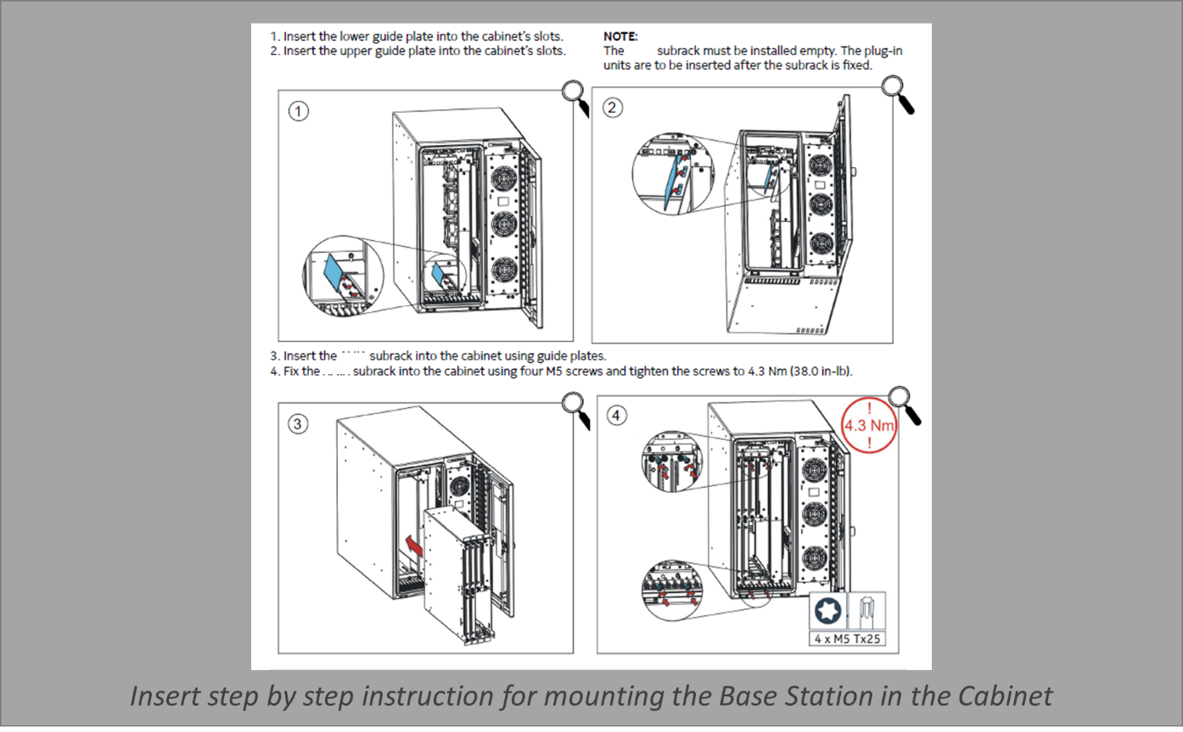

## Mounting Base Band Unit (Indoor Scenario)

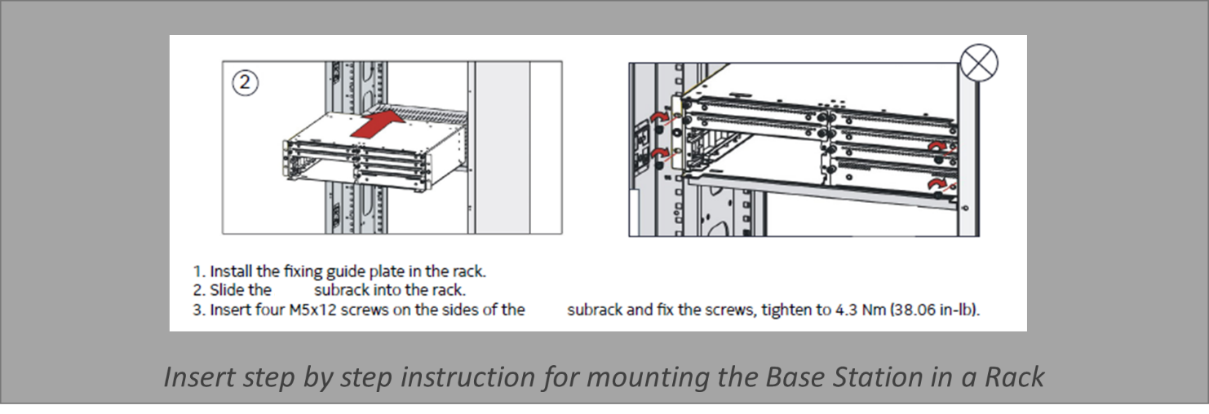

## Mounting Base band Boards

Please be aware that the board position depends on engineering specifications of NaaS Operator

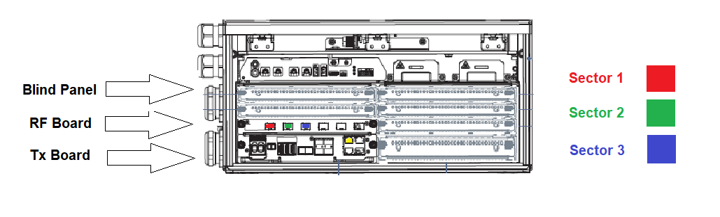

***Insert Engineering Diagram of Baseband Board Layout and fiber connections***

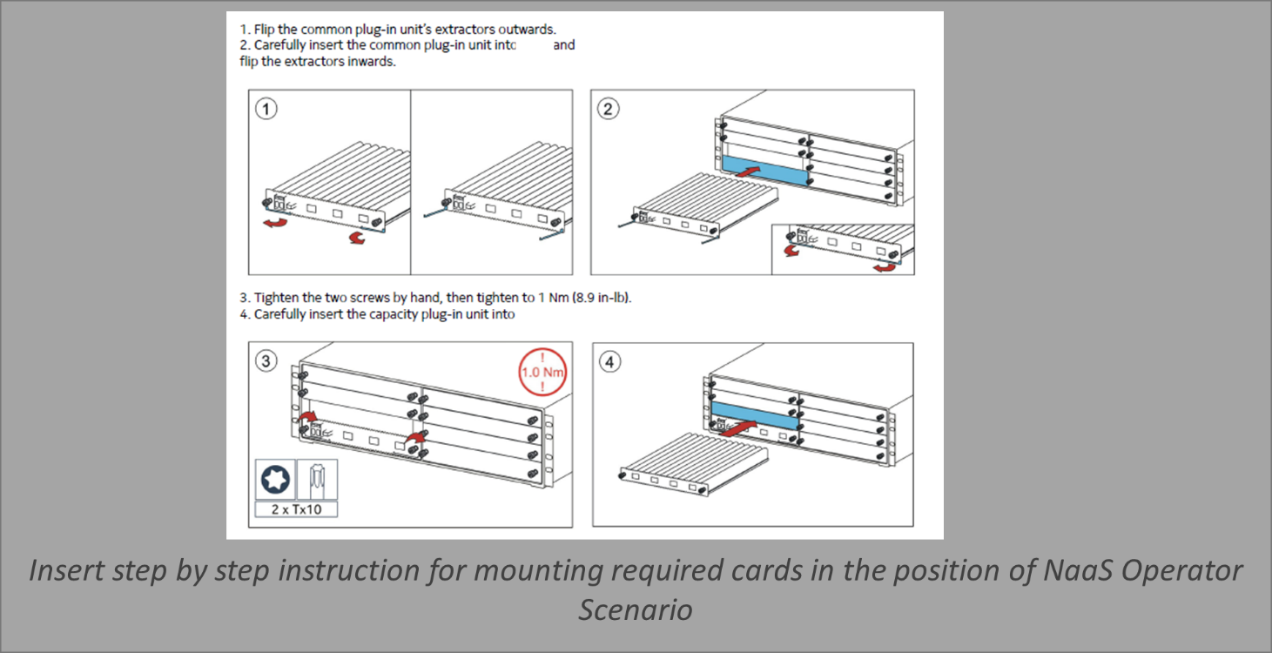

## Power Cabling the Base Band Unit

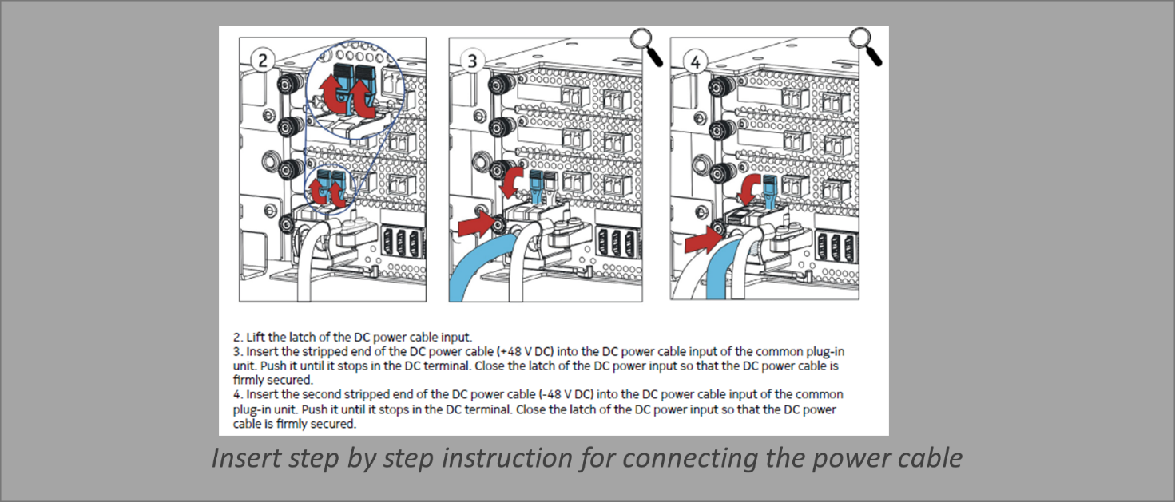

# Labeling

|  |  |  |  |
| --- | --- | --- | --- |
|  | **Labeling** | | |
| # | **Text** | ***Place of labeling*** | **Usage Remark** |
| **BTS Cabinet** | | | |
| 1 | BTS L PGND | *both ends of grounding cable* |  |
| 2 | BBU  -48V DC | *both ends of power cable* |  |
| 3 | BBU  0V DC | *on power cable end connected to 0V bar* |  |
| 4 | DBS -48VDC UPPER DCDU | *both ends of power cable* |  |
| 5 | DBS 0V DC UPPER DCDU | *both ends of power cable* |  |
| 6 | DBS -48VDC LOWER DCDU | *both ends of power cable* |  |
| 7 | DBS 0V DC LOWER DCDU | *both ends of power cable* |  |
| 8 | DBS UPPER DCDU | *on the FUSE in PSS cabinet* |  |
| 9 | DBS LOWER DCDU | *on the FUSE in PSS cabinet* |  |
| 10 | BTS L  Ethernet 0 | *both ends of transmission cable* |  |
| 15 | Upper TX BOARD MON0 to: TP SMU IooI | *the MON0 end of comunication cable* |  |
| 16 | TP SMU IooI to: Upper TX BOARD MON0 | *the IooI end of comunication cable* |  |
| 46 | **Optic fibers** | |  |
| 55 | **2100** |  |  |
| 56 | F_A_5 | *both ends of optic cable* |  |
| 57 | F_B_5 | *both ends of optic cable* |  |
| 58 | F_C_5 | *both ends of optic cable* |  |
| 62 | **RRU Power Cables** | |  |
| 71 | **2100** |  |  |
| 72 | P_A_5 | *both ends of DC power cable* |  |
| 73 | P_B_5 | *both ends of DC power cable* |  |
| 74 | P_C_5 | *both ends of DC power cable* |  |
| 78 | **Feeders/Jumpers** | |  |
| 93 | **L21** |  |  |
| 94 | A_5 | *both ends of jumpers and feeders* |  |
| 95 | A_6 | *both ends of jumpers and feeders* |  |
| 96 | B_5 | *both ends of jumpers and feeders* |  |
| 97 | B_6 | *both ends of jumpers and feeders* |  |
| 98 | C_5 | *both ends of jumpers and feeders* |  |
| 99 | C_6 | *both ends of jumpers and feeders* |  |

***Insert NaaS Operator Labeling Requirements***

# Annex A

Additional supporting information that should not be included in the document:

* Antenna Azimuth